

# AUGUST- 2023

**Programme : B.E / B. Tech**

**Course Code : CSA1190**

**Course Name** **: OBJECT ORIENTED ANALYSIS AND DESIGN**

**Date : 26-08-2023**

***LAB DAY-5***

1. **AGRICULTURE LOAN MANAGEMENT SYSTEM**

**USE CASE DIAGRAM:**

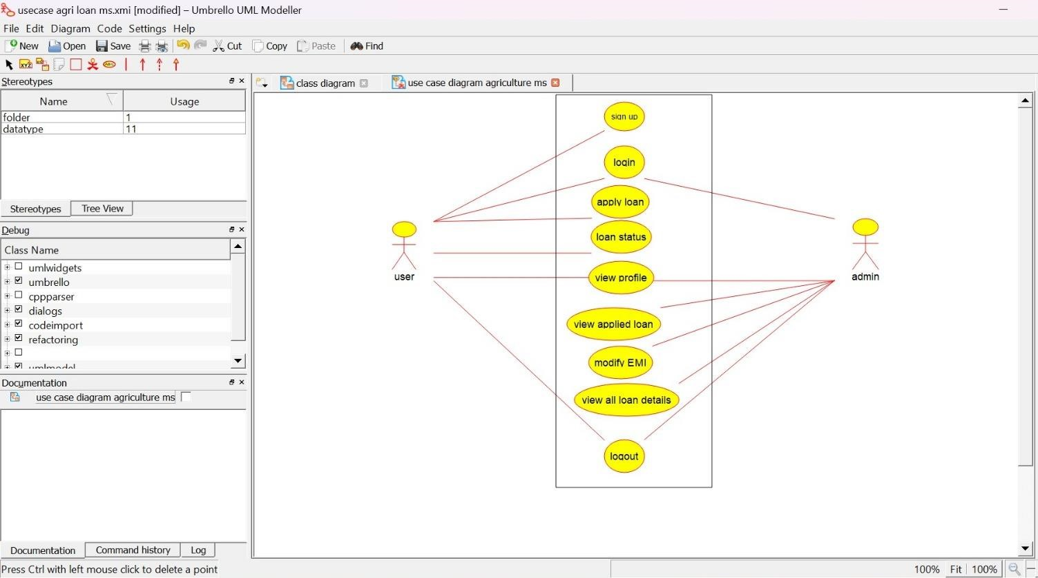

***ACTIVITY DIAGRAM:***

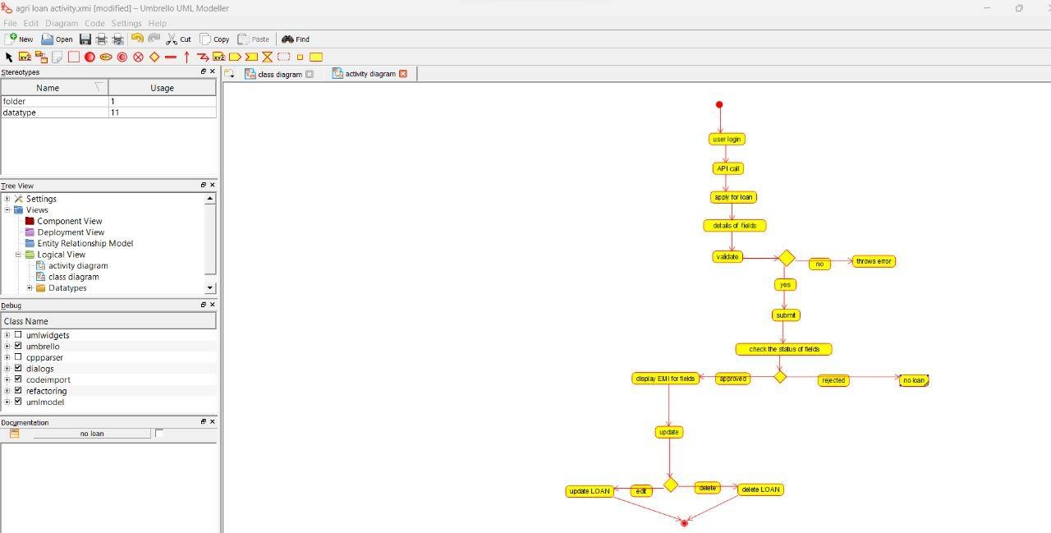

**SEQUENCE DIAGRAM:**

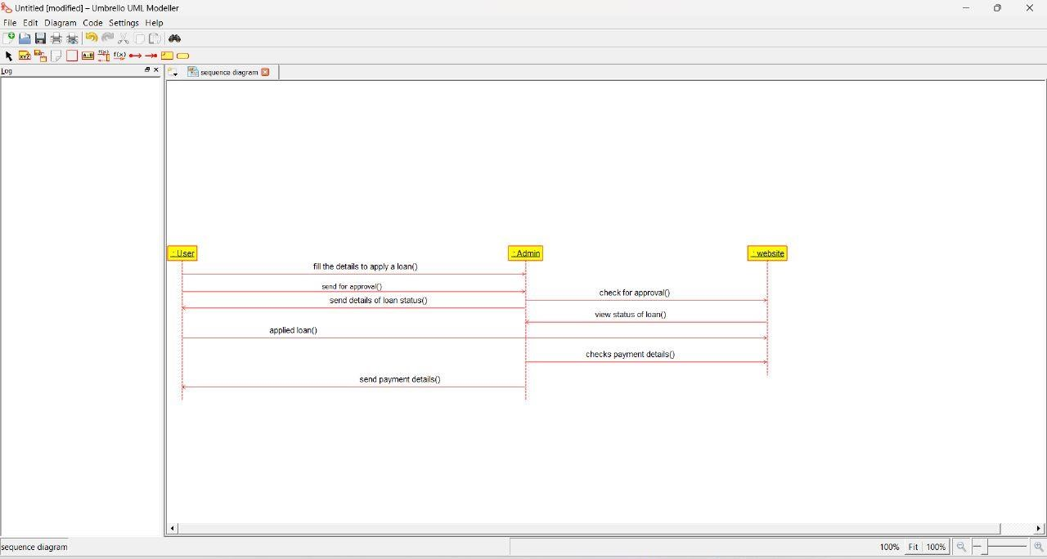

***JEWEL LOAN MANAGEMENT SYSTEM***

**USE CASE DIAGRAM:**

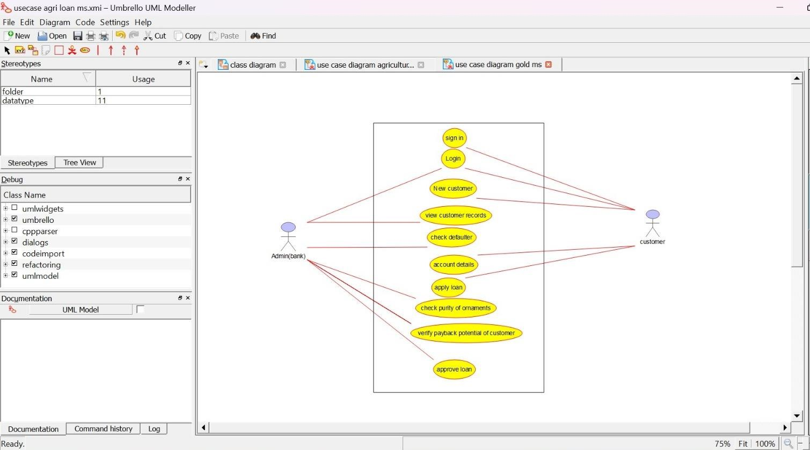

**CLASS DIAGRAM:**

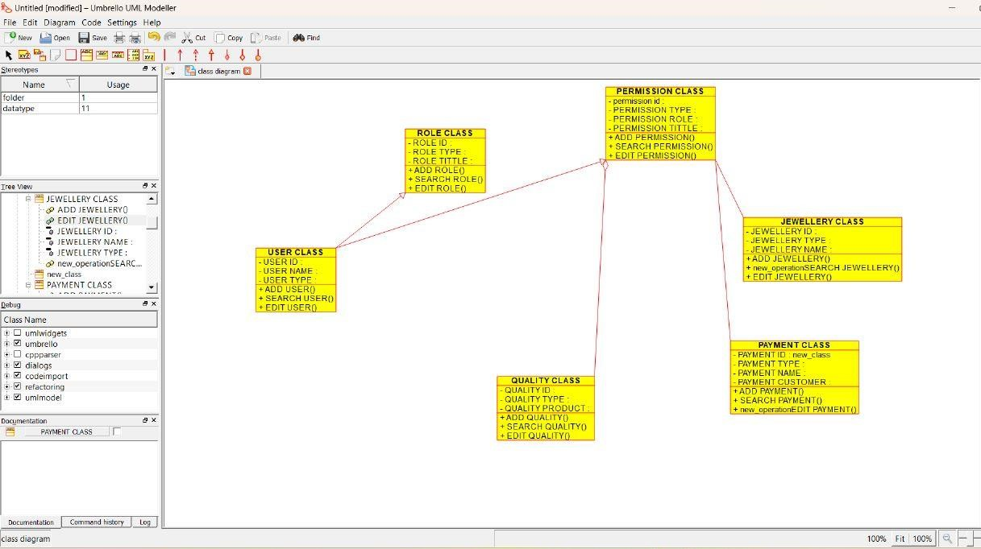

**ACTIVITY DIAGRAM:**

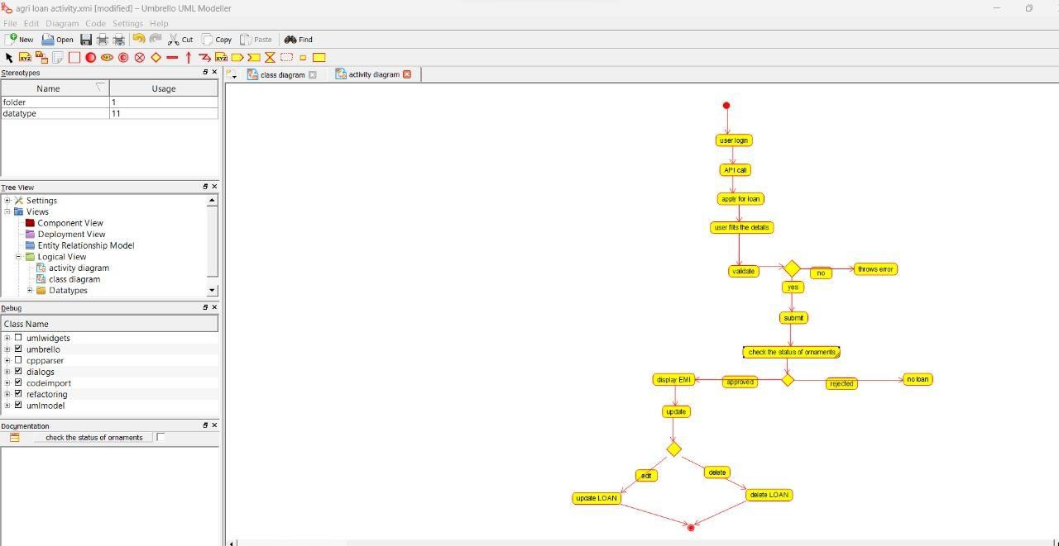

***PERSONAL LOAN MANAGEMENT SYSTEM***

**USE CASE DIAGRAM:**

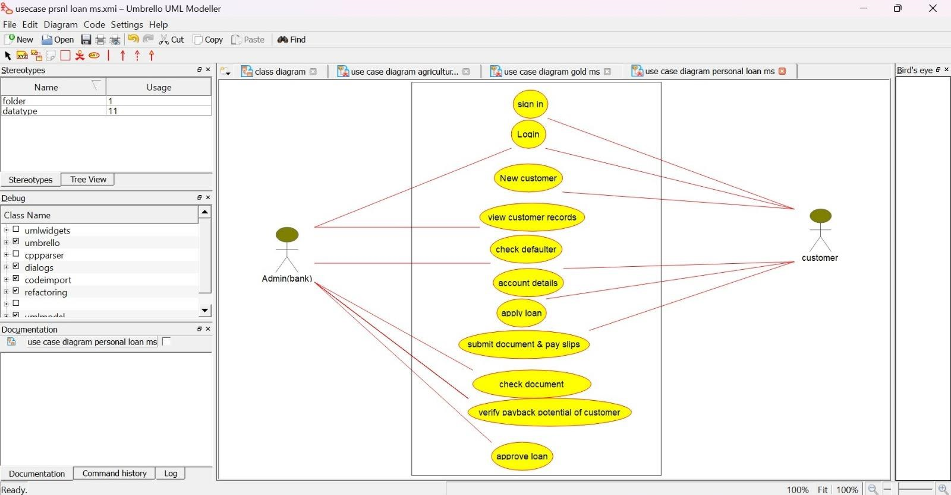

**CLASS DIAGRAM:** 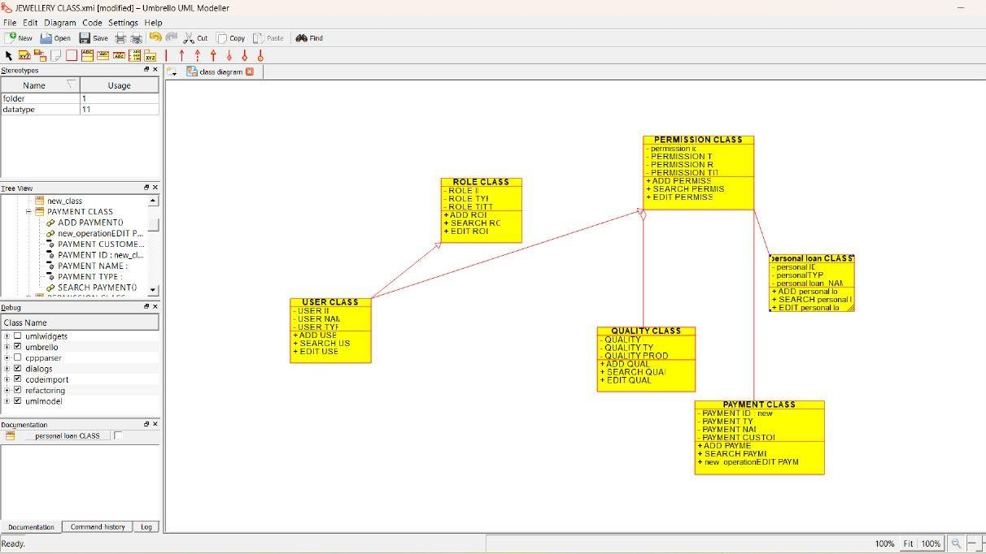

***SEQUENCE DIAGRAM:***

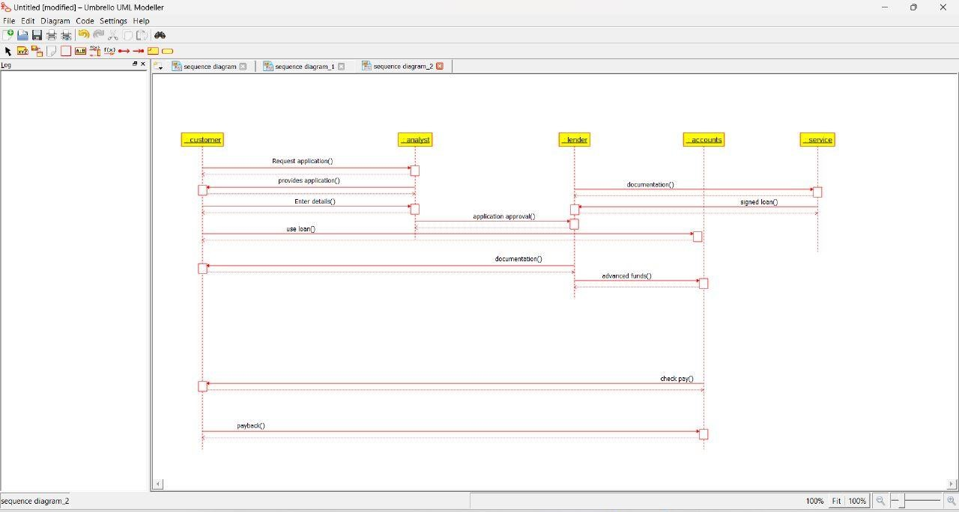

***HOME LOAN MANAGEMENT SYSTEM***

**USE CASE DIAGRAM:**

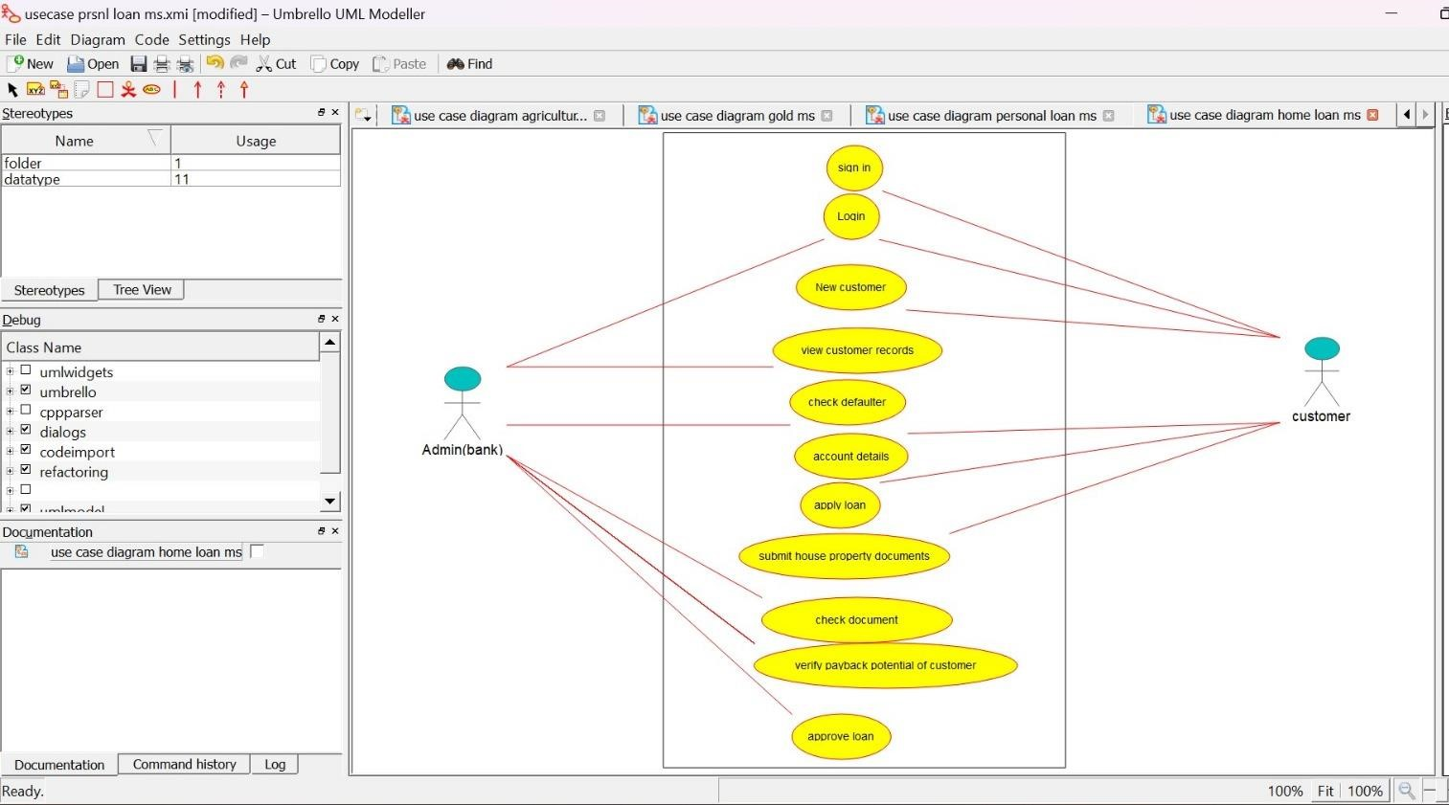

**CLASS DIAGRAM:**

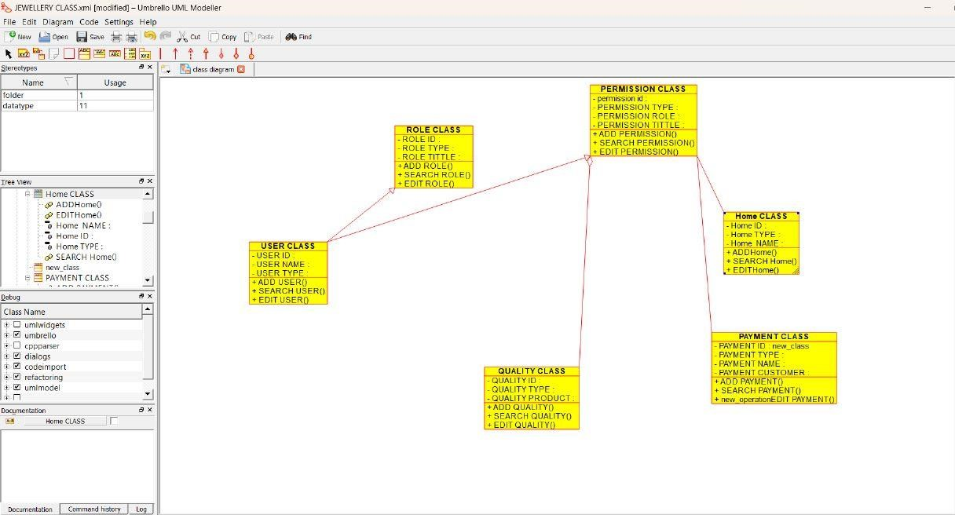

**ACTIVITY DIAGRAM:**

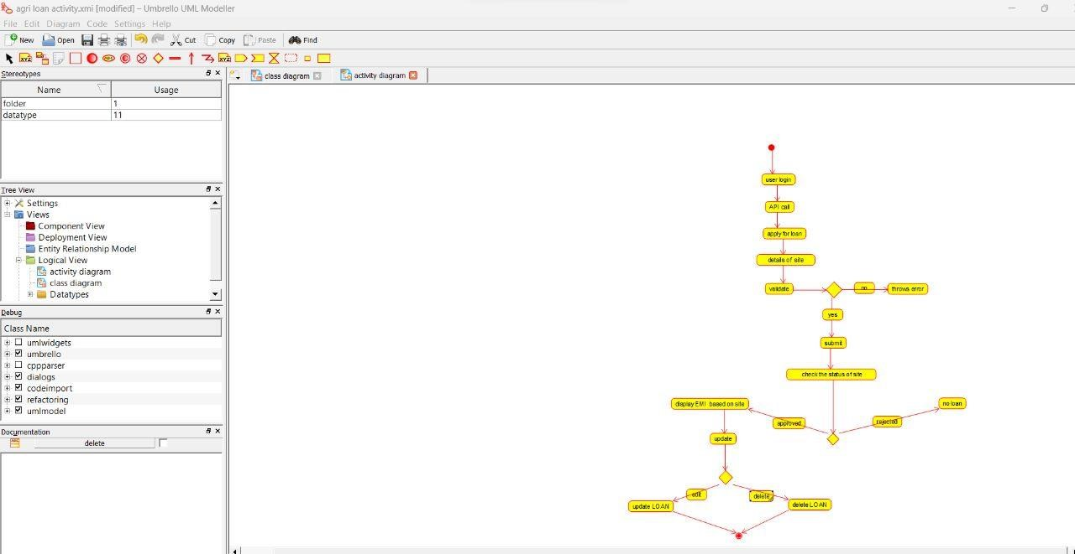

***LAND REGISTRATION SYSTEM***

***USE CASE DIAGRAM:***

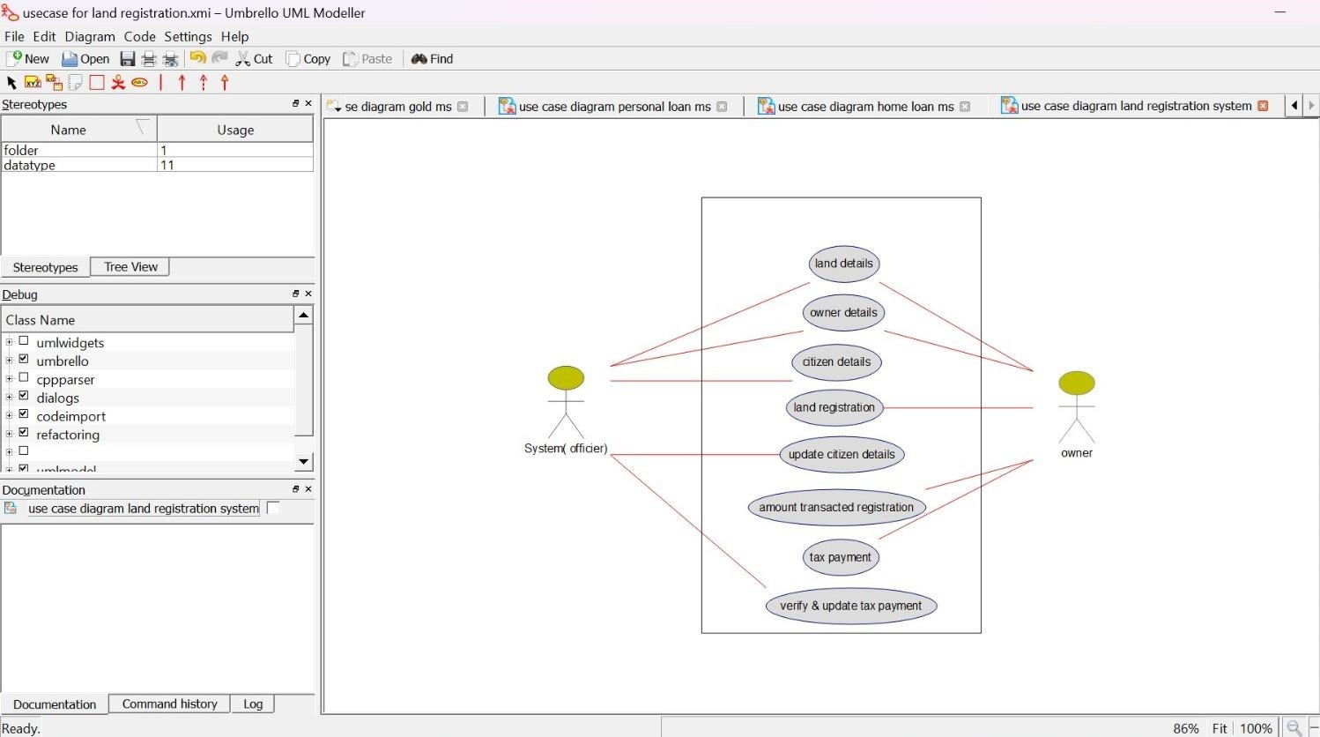

**CLASS DIAGRAM:**

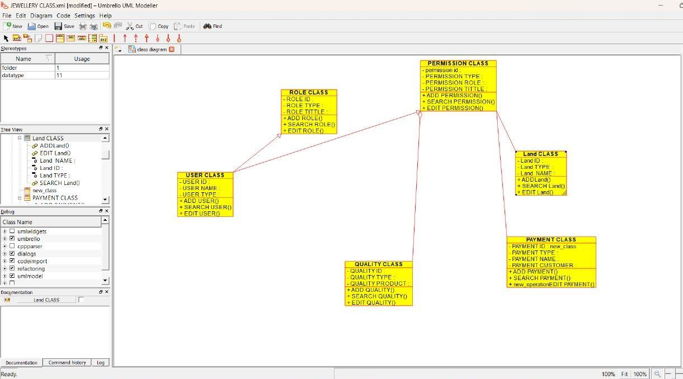

**ACTIVITY DIAGRAM:**

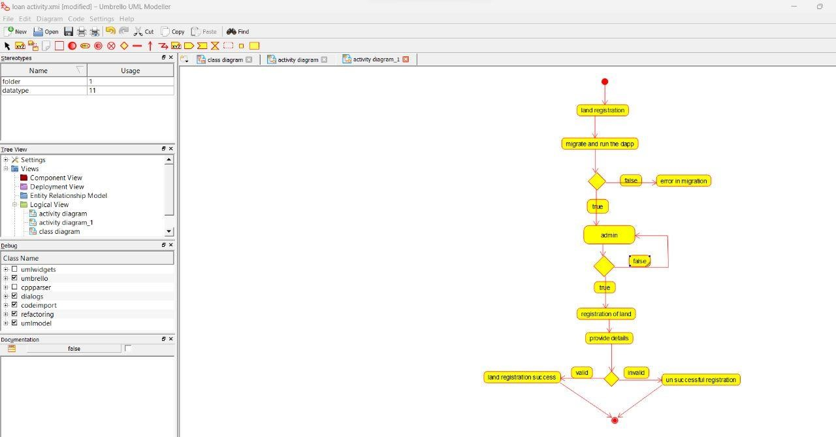

***VEHICLE BOOKING SYSTEM***

**USE CASE DIAGRAM:**

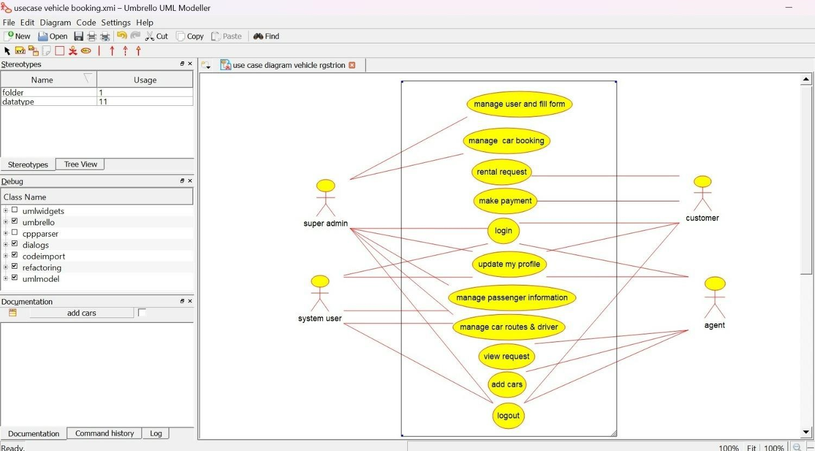

**CLASS DIAGRAM:**

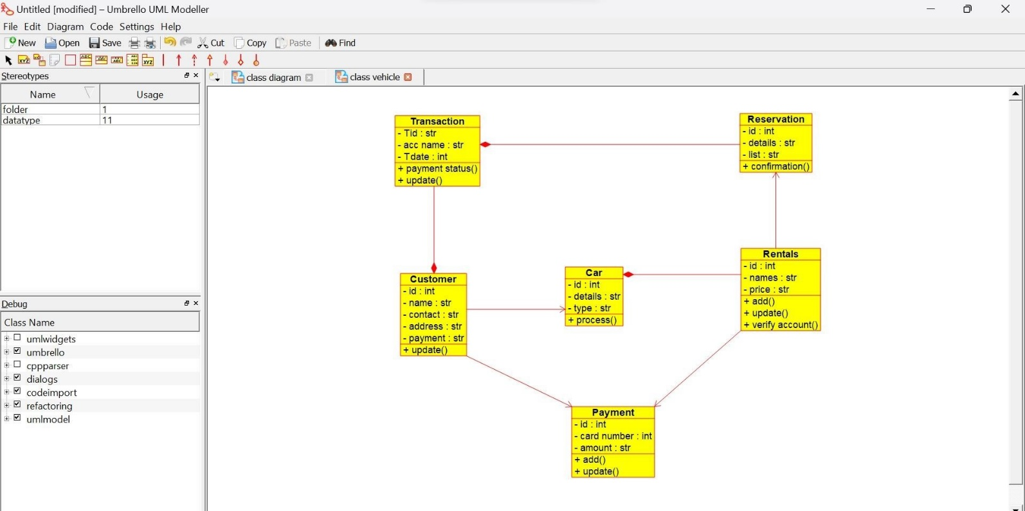

**SEQUENCE DIAGRAM:**

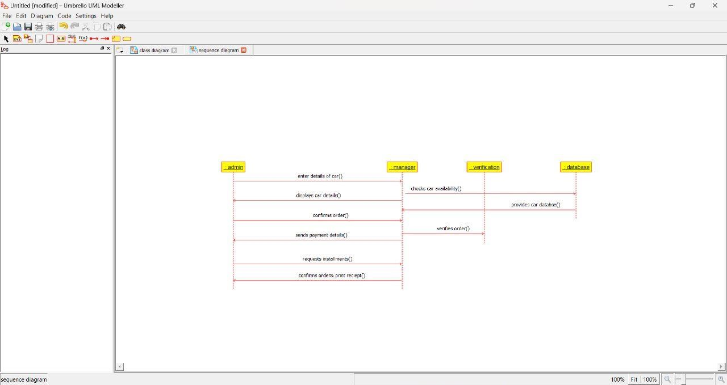

**DOCTOR APPOINTMENT SYSTEM USE CASE DIAGRAM:**

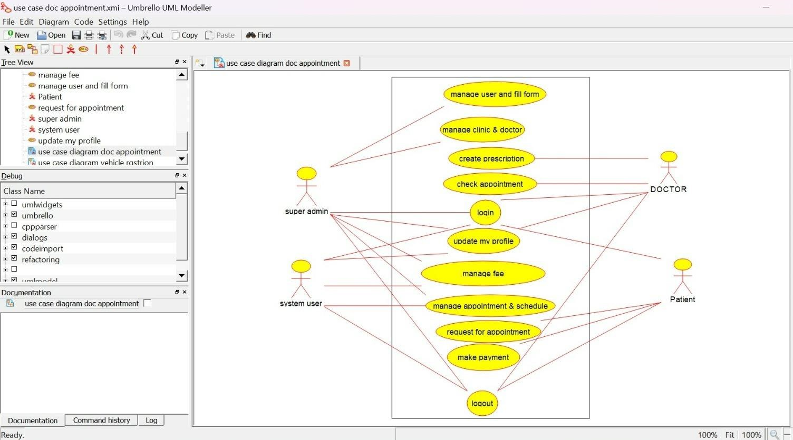

**CLASS DIAGRAM:**

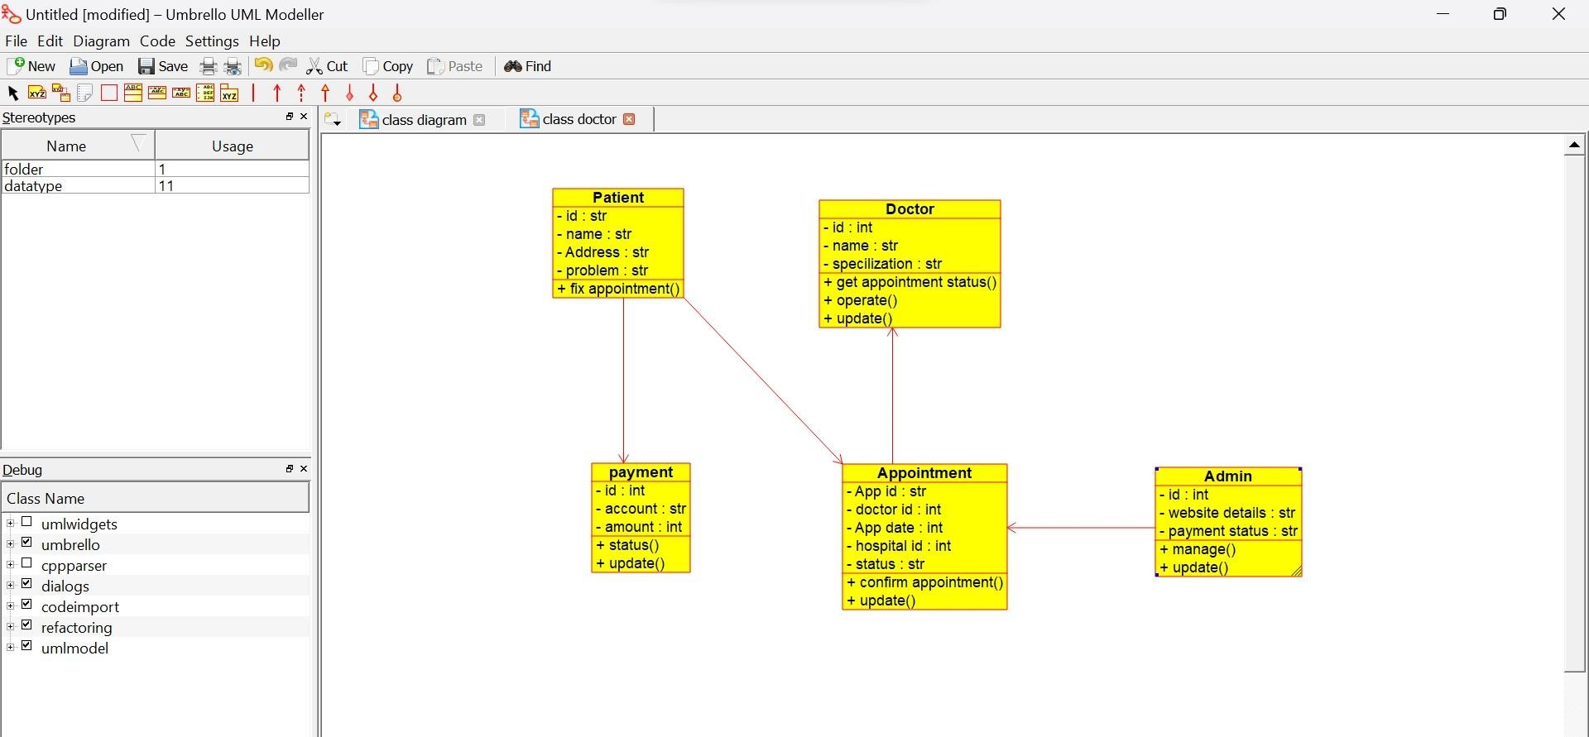

**ACTIVITY DIAGRAM:**

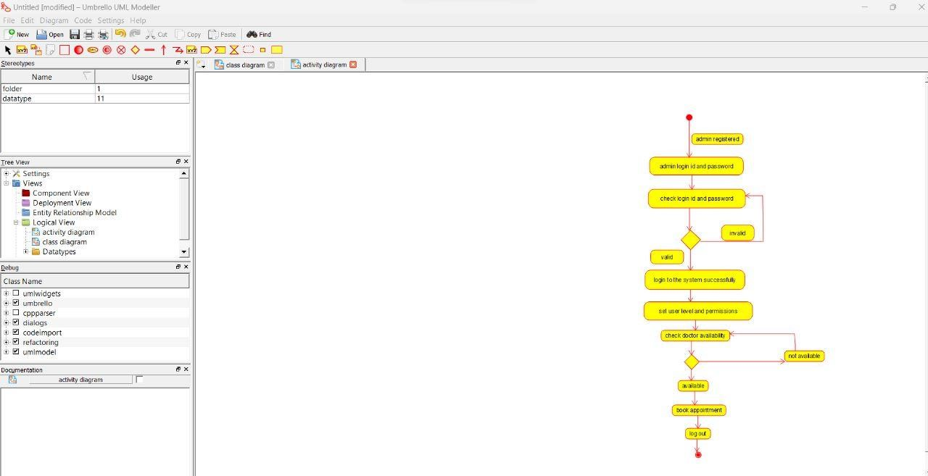

**PARLOR RESERVATION SYSTEM**

***USE CASE DIAGRAM:***

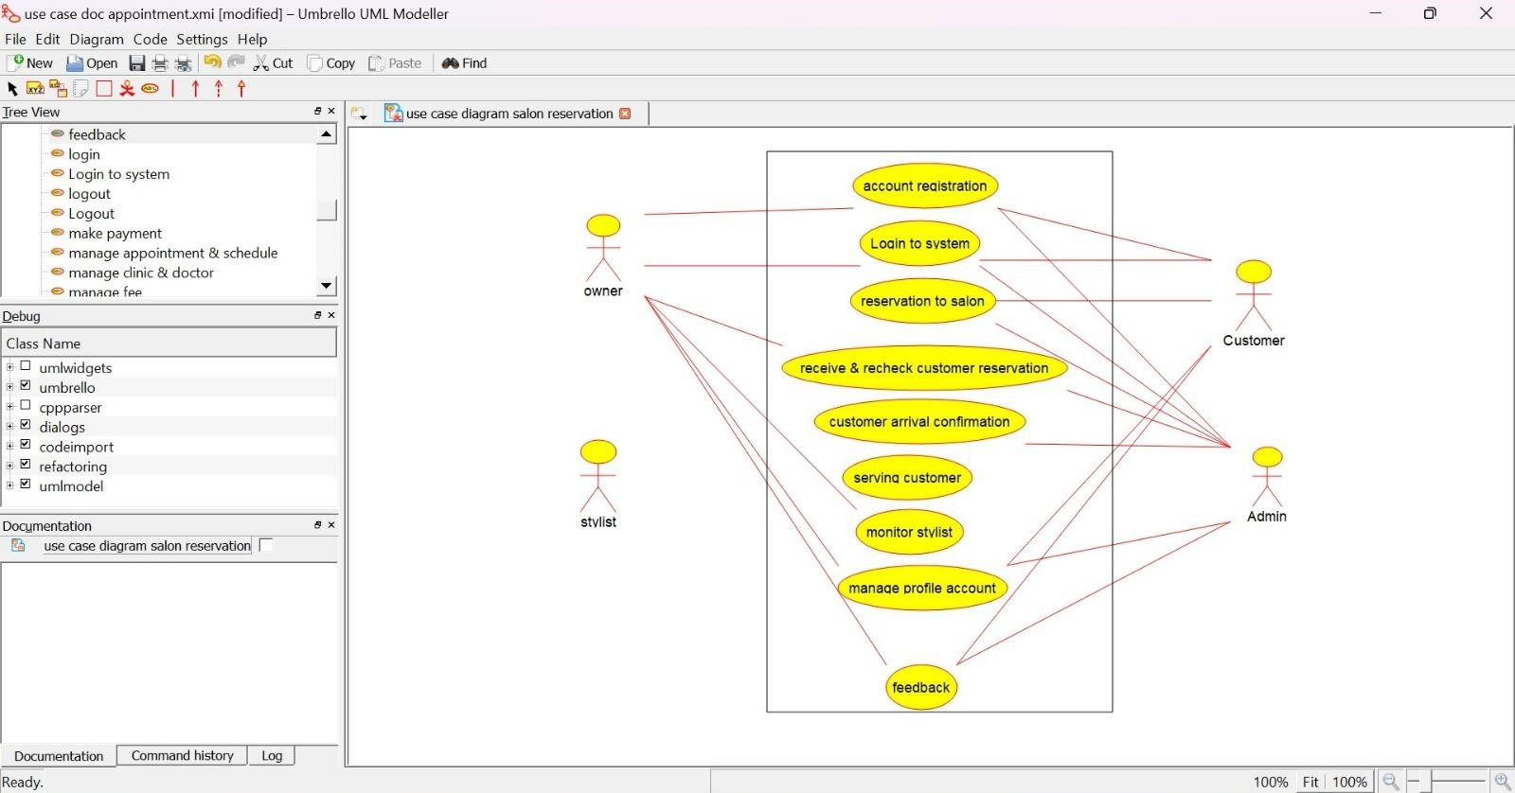

**CLASS DIAGRAM:**

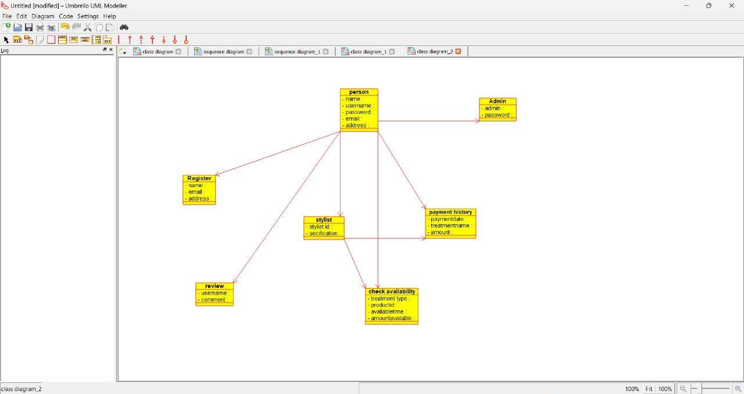

**SEQUENCE DIAGRAM:**

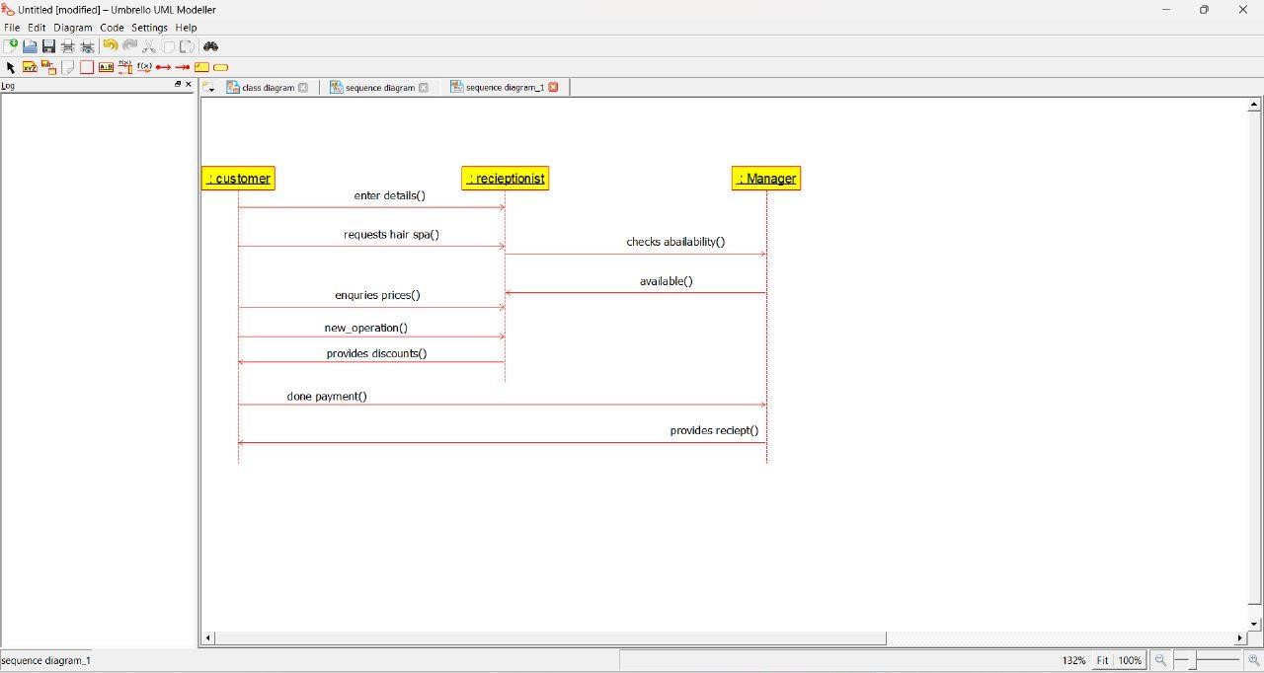

**GARDENER BOOKING SYSTEM**

***USE CASE DIAGRAM:***

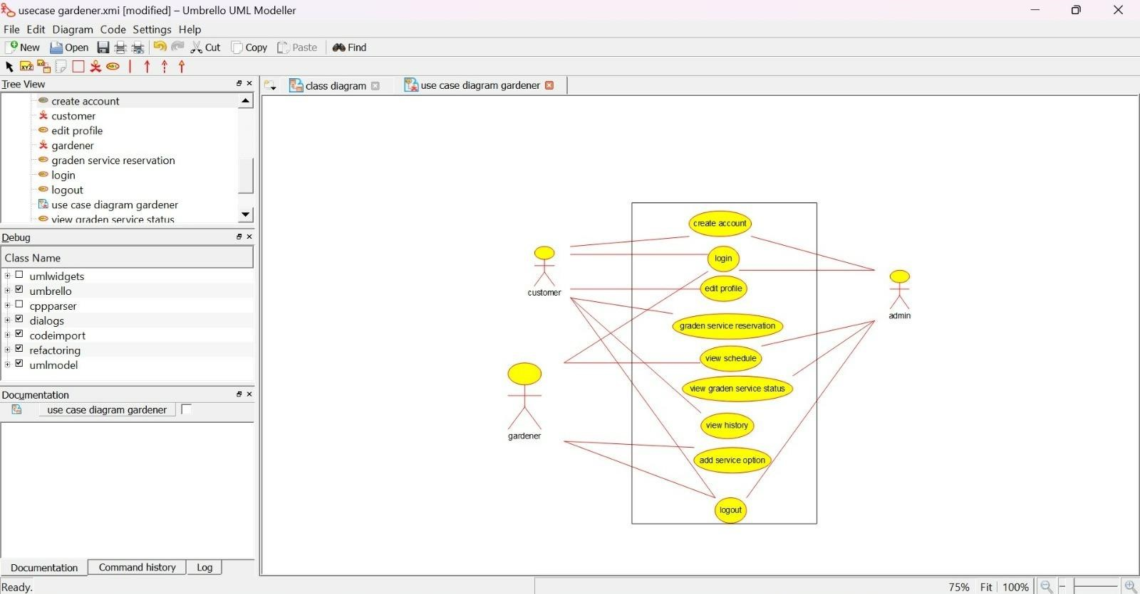

***CLASS DIAGRAM:***

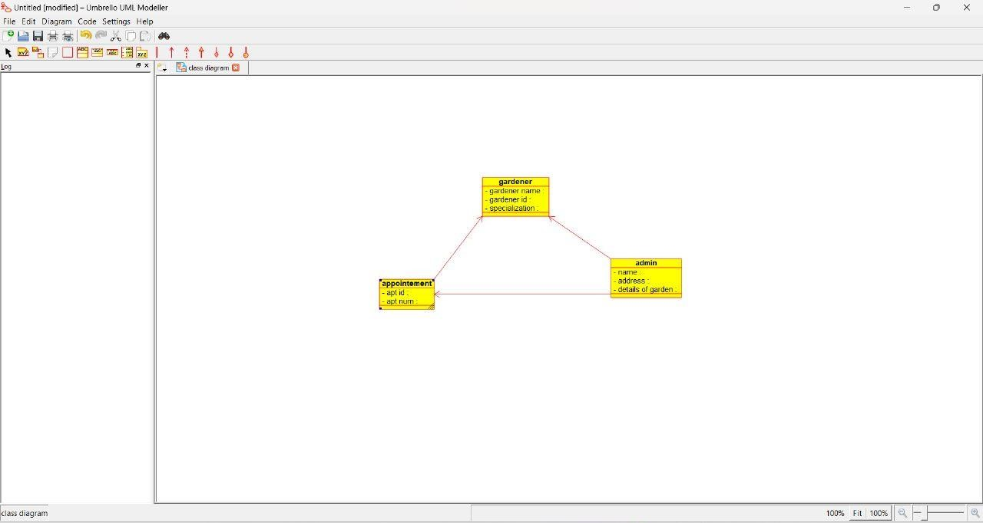

**SEQUENCE DIAGRAM:**

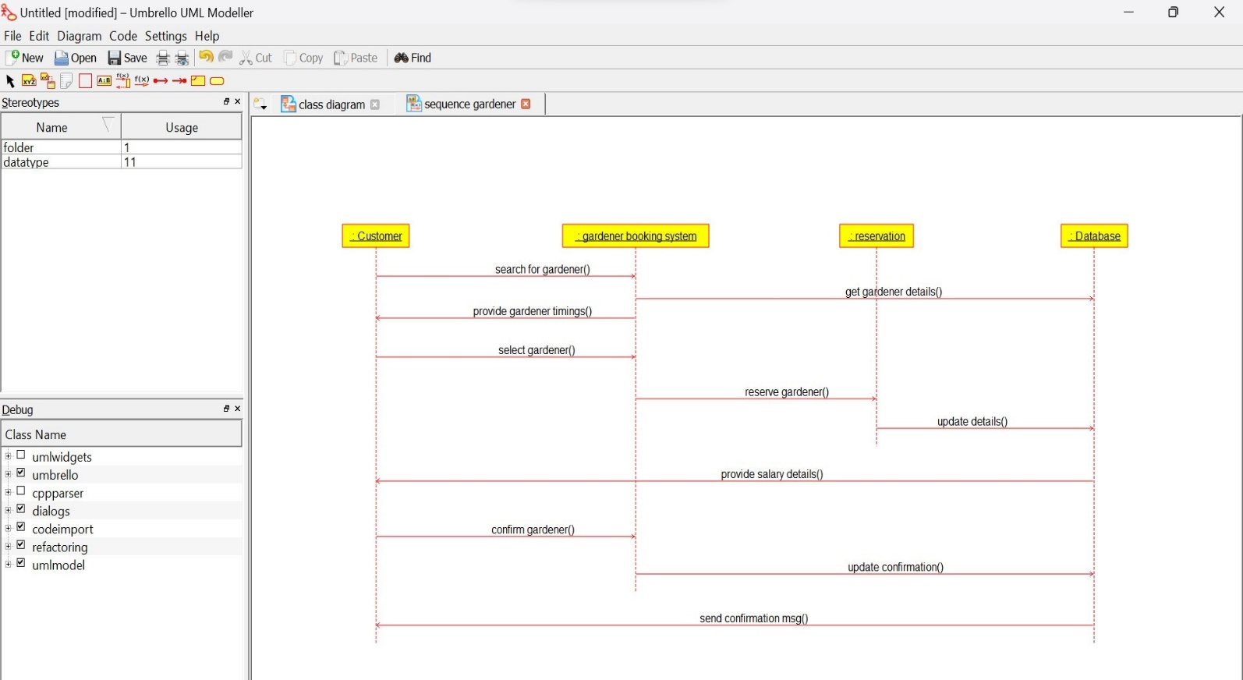

**HOME TAX COLLECTION SYSTEM USE CASE DIAGRAM:**

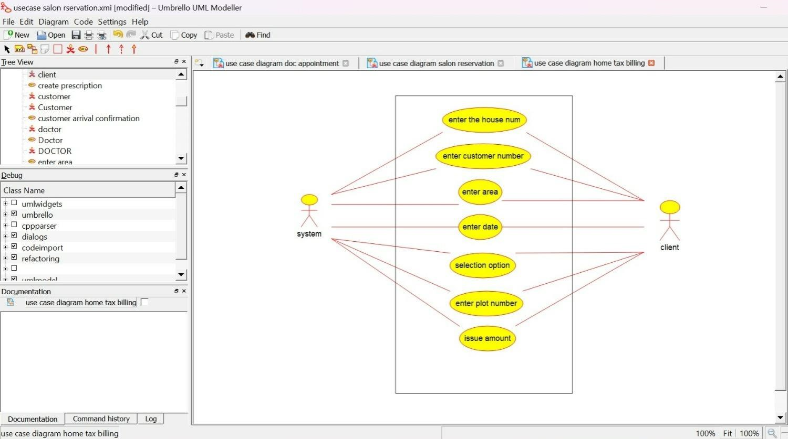

***CLASS DIAGRAM:***

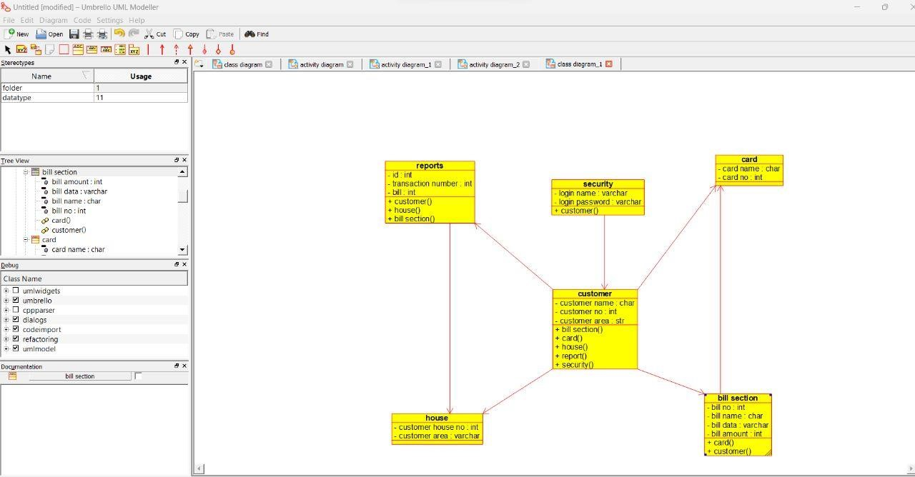

**ACTIVITY DIAGRAM :**

